Upcoming Events

Aug. 27th – School Pictures

Sept. 2nd – No School

Sept. 19th – Parent Teacher Conferences

Week of Aug. 26

**Next Week**

Next week we will dive into our new math curriculum – Investigations. In Language Arts, we will spend the first couple of weeks reviewing the alphabet and then moving on. This week we will be reviewing the first half of the alphabet. Our story is Animals in the Park. We will be working on completing sentences that begin with I.

**This Week**

We survived!!! It was a long week for all the little ones…it is difficult to get used to being on the go all day and Corn Palace Week just adds to the fun! This week was full of exciting experiences as we met new teachers (gym teacher, computer teacher and classroom helper) and friends. We spent most of our time reviewing and learning new expectations and procedures to make our day run smoother.

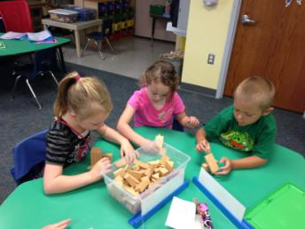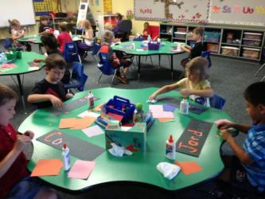

Exploring with our new geo blocks

Future Newsletters

I will be emailing the future newsletters and linking them to my website under the newsletter tab. If you did not receive this newsletter via email, I do not have an accurate account! Drop me a note of your new email address. Also, please let me know if you prefer a paper copy.

Contact Me:

Email – [amy.j.christensen@k12.sd.us](mailto:amy.j.christensen@k12.sd.us)

Website – http://ac069.k12.sd.us

REMINDER:

Please be reading to your child 20 minutes each night and documenting one title on your record sheet

WANTED…

Small treats, toys, stickers, etc… to replenish our prize box!

SMILE!

School pictures are on Tuesday morning. All children will have their pictures taken for the year book.

Working on our small motor skills while creating our name by tearing small paper