Upcoming Events

Sept. 2nd – No School

Sept. 6th – Book Orders Due

Sept. 19th – Parent Teacher Conferences

Week of Sept. 2nd

**This Week**

This week we started right in with the alphabet and numbers 1 through 10. We reviewed a letter or 2 a day and ended with Hh. I introduced the sight word “I”. We worked hard speaking and answering in sentences. In writing, I introduced the word web to collect our thoughts. Their sentence started with I am… In math, we have been working on counting, number recognition to 10 and exploring with our new manipulatives. Our focus was the attendance and calendar procedure.

**Next Week**

Next week we will continue working on the letters through R. Our sight word is “can”. Our big book is a non-fiction book titled, Our Hands Can. We will be comparing our fiction story from last week with our non-fiction book this week. We will start working on rhyme, syllable blending and opposites. In math, we will continue with number formation and recognition.

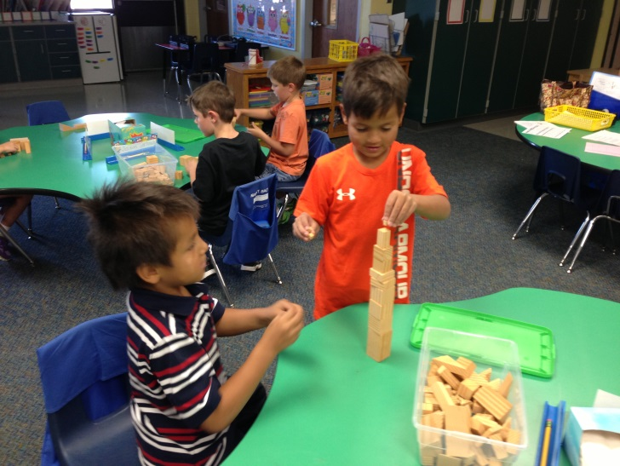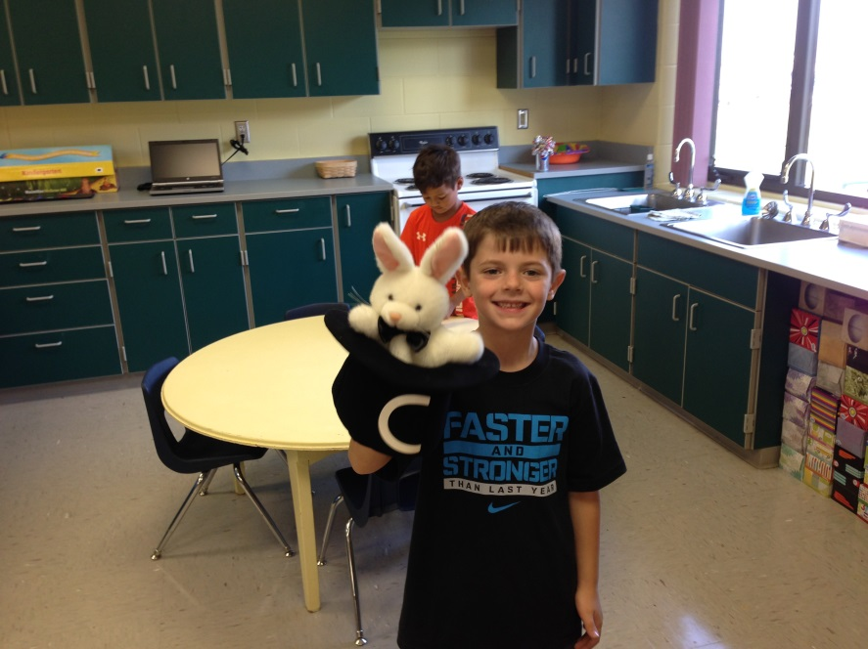

Magic C helps us with forming our letters!

REMINDER:

Please send a snack for 18 children on your child’s assigned snack days – this week is T-Camdyn; W-Carter; Th-Charlie; F-Cooper

Contact Me:

Email – [amy.j.christensen@k12.sd.us](mailto:amy.j.christensen@k12.sd.us)

Website – http://ac069.k12.sd.us

Water bottles

The children can have a water bottle due to the high temps and to drink with afternoon snack.

Thank you for those that donated prizes and treats for the prize box! I appreciate the help!

Scholastic Book Orders

I send home book orders at the beginning of each month. Please do not feel obligated to buy any…however, for those that like to buy books, they usually are a great deal. You can buy online with our class code (see letter attached) or send the order to school with a check made to Scholastic Books by the due date.

Exploring with our Geo Blocks in math

Come and Go Blue Folders

There are lots of things we keep in this folder so I thought I would not use the parent / teacher communication form this year…well after 2 weeks I realize that I made a mistake – We NEED a place to write notes back and forth! So, on their behavior clip chart calendar I added a section for notes each week. This is where we can leave notes or questions. For example, if something changes in their transportation plan or if they are going to be absent. We will try this for a few weeks and if we need more room, I will go back to the drawing board! I just do not want their reading record sheet and behavior calendar to get mixed in with their papers and left at home so I think they each need their own place!