Upcoming Events

Sept. 16th – 20th – Book Fair

Sept. 19th – Parent Teacher Conferences

Week of Sept. 9th

**This Week**

This week we continued to review the letters of the alphabet. Our sight word was can. We focused on answering questions in complete sentences. In math, we finished our first investigation. We continue to work on number sense. We have been working hard on our listening skills by determining the beginning and ending sounds in words. Determining which two words rhyme was another skill we worked on this week.

**Next Week**

Next week we will finish reviewing the alphabet. We will focus on the words: am and go. Our trade book will be Jazz Baby. We will also be doing activities to review the alphabet by reading Chicka Chicka Boom Boom. We will continue working on determining the sounds that create a word. We will be counting syllables by clapping them out. In math, we will be starting our 2nd Investigation – The Counting Jar. This unit focuses on quantity and counting.

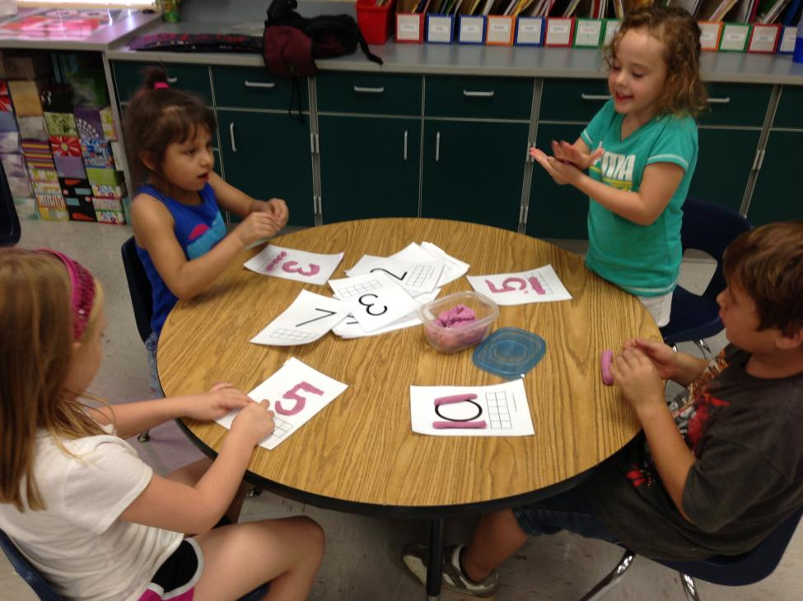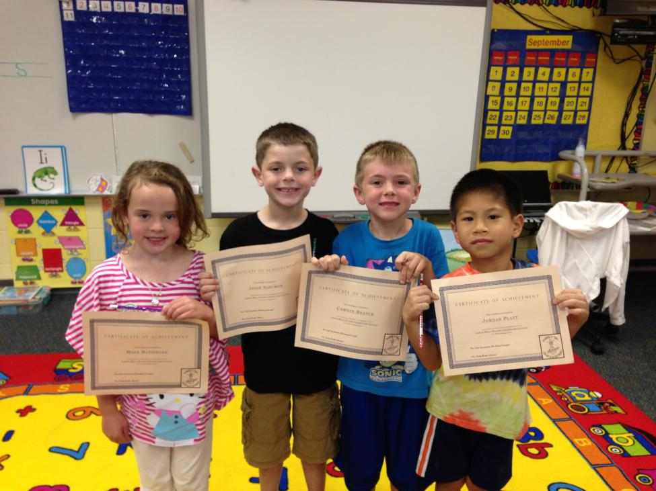

Library

We do not have a specific library day this year. The children can go any day they bring back their book. It is their responsibility to keep track of their book and know if they need a new one.

Thursday and Friday

I apologize in advance, but I will be absent on Thursday and Friday. My husband is having an unexpected surgery on Thursday and I will be with him in Sioux Falls. Your children will be in great hands with Mrs. Weigant (a retired kindergarten teacher) and Mrs. Williams. With this in mind, I will be emailing the newsletter over the weekend and you will get a paper copy on Monday instead of Friday.

Congratulation Summer Readers!!

REMINDER:

Please send a snack for 18 children on your child’s assigned snack days – this week is M – Emily; T- Haidlee; W- Hope; Th- Jaxson; F- Jordan

Contact Me:

Email – [amy.j.christensen@k12.sd.us](mailto:amy.j.christensen@k12.sd.us)

Website – http://ac069.k12.sd.us